***Memory Notes***

Memory: It's our ability to retain knowledge. Without memory, we wouldn't be able to recall past experiences, learn from them, or retain information.

**Process of Memory:**

**Encoding**: This is the process where we take in information through our senses and convert it into a form that can be stored in our memory.

**Storage**: This involves maintaining the encoded information over time so that it can be used later.

**Retrieval**: This is the process of recalling stored information when we need it.

**Information** **Processing**: This is a continuum that involves several stages, including:

**Attention**: Focusing on specific stimuli.

**Sensation**: Detecting stimuli from the environment.

**Perception**: Interpreting these stimuli.

**Learning**: Acquiring new knowledge or skills.

**Memory**: Storing and retrieving this knowledge.

**Cognition**: Using this knowledge for thinking and problem-solving.

1. **Sensory Memory** is like a super short-term memory that holds a lot of information from our senses (like what we see, hear, or touch) for a very brief moment. Imagine it as a quick snapshot or a flash of what you just experienced before it fades away.

Here’s a simple example:

* When you glance at a scene for a second, sensory memory holds that image for a tiny moment, helping you decide what's important to focus on or remember.

**Function**: It processes basic physical characteristics of the information.

**Capacity**: It's like a giant holding tank that can hold a lot of information at once.

**Duration**: It retains information for a very brief period:

* About 3 seconds for visual information (like what you see)
* About 2 seconds for auditory information (like what you hear)

**Types**:

* **Iconic Memory**: For visual information. Think of it like a quick snapshot (e.g., the image you see right after turning off a flashlight).
* **Echoic Memory**: For auditory information. Imagine the sound lingering for a moment (e.g., the honk of a car).

**Types of Sensory Memory:**

**🡺 Haptic Memory**:

* **Function**: Deals with touch and physical sensations.
* **Example**: Feeling the texture of an object or the sensation of a breeze on your skin.

**🡺 Echoic Memory**:

* **Function**: Processes auditory (hearing) information.
* **Example**: Remembering the sound of a car honking or someone speaking to you for a few seconds.

**🡺 Iconic Memory**:

* **Function**: Processes visual (seeing) information.
* **Example**: The image of a flashlight turning off, which lingers in your vision for a brief moment.

**🡺 Olfactory Memory**:

* **Function**: Handles smells.
* **Example**: Remembering the smell of fresh cookies or a particular perfume.

**🡺 Gustatory Memory**:

* **Function**: Deals with taste.
* **Example**: Recalling the taste of your favorite food or drink for a short period.

**2. Short-Term Memory (STM) / Working Memory**

**Function**:

* Short-term memory is like a temporary workspace in your brain.
* It's where you actively process and work with information.
* For example, *🡪* ***when you're solving a math problem in your head or remembering a phone number just long enough to dial it, you're using short-term memory.***

***🡪 Remembering a short shopping list before writing it down.***

**Capacity**:

* Short-term memory can hold a limited amount of information at once.
* It usually holds about 7 items, but it can range from 5 to 9 items (hence, 7 ± 2 items).

**Duration**:

* The information in short-term memory doesn't last very long—only about 25 seconds.
* If you don’t actively work on or rehearse the information, it will quickly fade away.

**Transition from Sensory Memory to Short-Term Memory**

* Information first enters **Sensory Memory**, where it is briefly held.
* To move this information into **Short-Term Memory**, you need to pay attention to it

***3. Chunking:***

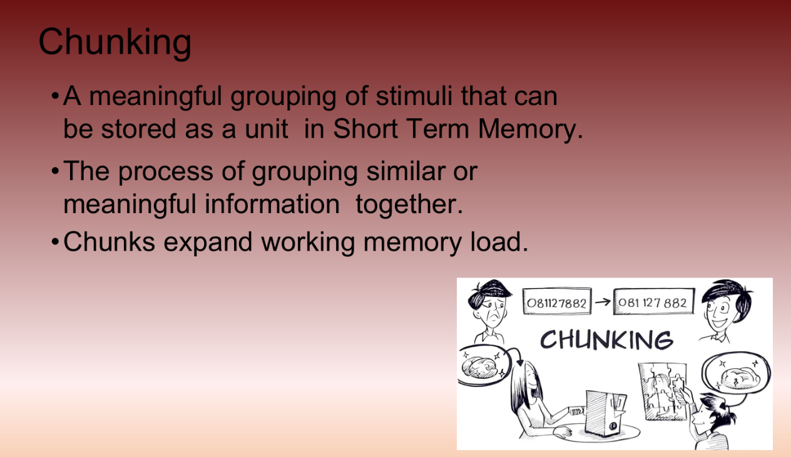

***4. Long Term Memory:***

**Function**:

* Long-term memory is like your brain's filing cabinet where information is stored permanently.
* It allows you to retain information for long periods, from days to even decades.

**Duration and Capacity**:

* LTM has an almost unlimited capacity, meaning it can store vast amounts of information.
* Memories in long-term memory can last for years, sometimes even for your entire lifetime.

**How It Works:**

* Information gets transferred to long-term memory from short-term memory through processes like rehearsal (repeatedly thinking about it) and making the information meaningful (connecting it to something you already know).
* Once stored, information in LTM can sometimes be hard to retrieve, but it's there when needed.

**Examples:**

* **Childhood Memories**: Remembering your childhood home or your first day of school.
* **Skills and Knowledge**: Knowing how to ride a bike or play an instrument.
* **Facts and Information**: Recalling historical dates or scientific facts.
* **Favorite Songs and Lyrics**: Remembering the lyrics to your favorite song from years ago.

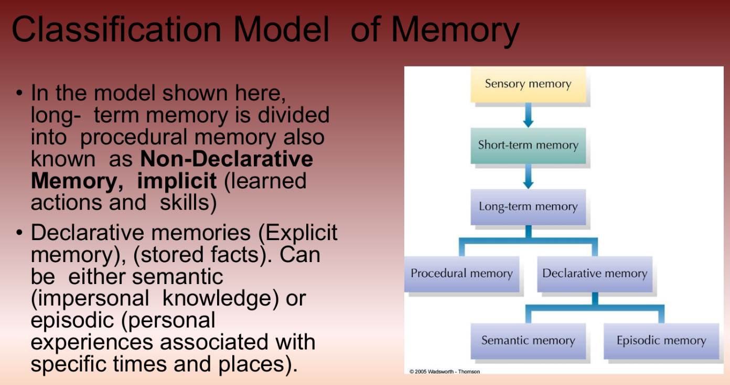***i. Declarative Memory:***

***🡺 Semantic Memory:***

**Definition**:

* **Semantic memory** is like your mental encyclopedia. It stores general knowledge and facts about the world, concepts, and language.

**Examples**:

* Knowing that Paris is the capital of France.
* Remembering that 2 + 2 = 4.
* Understanding the meaning of words and concepts.

**Characteristics**:

* Semantic memory is impersonal; it doesn’t relate to personal experiences but rather to information.

***🡺 Episodic Memory:***

**Definition**:

* **Episodic memory** is like your personal diary. It stores autobiographical events and experiences, including the context in which they occurred (like time and place).

**Examples**:

* Recalling your last birthday party.
* Remembering your first day of school.
* Visualizing a vacation you went on.

**Characteristics**:

* Episodic memory is personal; it relates to specific events and experiences In your life.

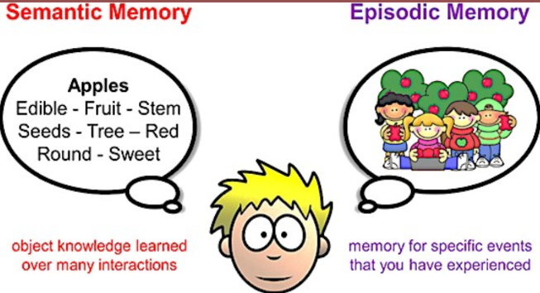

***ii. Non-Declarative Memory (Procedural Memory)***

**What is it?**

* Procedural memory is the type of memory that helps you perform tasks without having to think about them step by step. It's like an autopilot for skills and habits you've learned.

**How does it work?**

* Once you've practiced something enough, your brain remembers how to do it automatically. You don't have to consciously think about each step.

**Examples:**

1. **Riding a Bike**:
   * When you first learned to ride a bike, you had to think about balancing, pedaling, and steering. But now, you can just hop on and ride without thinking about each part.
2. **Typing on a Keyboard**:
   * At first, you had to look at each key and remember where the letters are. Now, you can type quickly without looking because your fingers just know where to go.
3. **Tying Your Shoelaces**:
   * Remember when you learned to tie your shoelaces? You had to remember each step. Now, you do it without even thinking about it.

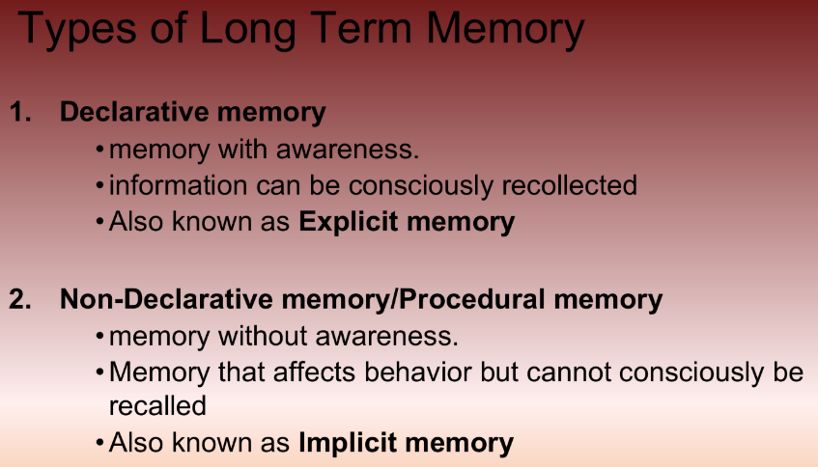

***~Fin.***